Important Information

PLEASE READ & COMPLETE THE ENTIRE FORM, MISSING INFORMATION MAY DELAY YOUR APPLICATION.
Hertford Town Council reserves the right to decline stallholders a pitch if not appropriate for the event or if a vendor has already secured a pitch selling similar products.
No ice cream vans please.
Food vendors ARE permitted to sell cold drinks but are NOT permitted to sell hot drinks.
Weather: Events will go ahead if it rains. If, for safety reasons due to the adverse weather conditions (decisions will be made at the discretion of Hertford Town Council), the event is cancelled you will be notified by 12pm on the Thursday before the event day. If you have received no communication from us, detailing that the event is cancelled by the Thursday before the event, then the event will go ahead as planned.
Refunds: Please note that once you have returned the booking form and made payment, Hertford Town Council will not offer a refund on the pitch secured. If you are unable to attend, please let us know as soon as possible, and if we are able to rebook your allocated pitch, then we will potentially be able to reimburse the amount paid.
COVID-19: A review date for each event is in place to assess the situation and decide whether the event will take place. Hertford Town Council reserve the right to cancel the event and will notify you if this happens. In the event of a cancellation due to Covid-19, you will be eligible for a full refund or the option to transfer your deposit to the next year.
Please Note:
- Standard pitch sizes are 3m x 3m, please specify if your dimensions vary from this as the price may also vary.
- You will need to provide your own gazebo, tables and chairs if you require them. For chalet bookings, the chalets are provided and installed empty.
- Cars cannot be left on the lawn during the event or in the Castle car park.
- Width restrictions accessing the grounds for large vehicle (Main lawn access: smallest width 3 metres, there’s a tight corner. For long vehicles a site visit is recommended – Island lawn access: smallest width 2.2 metres)
- Traders must provide a waste bin for their customers and ALL trade waste must be taken away.
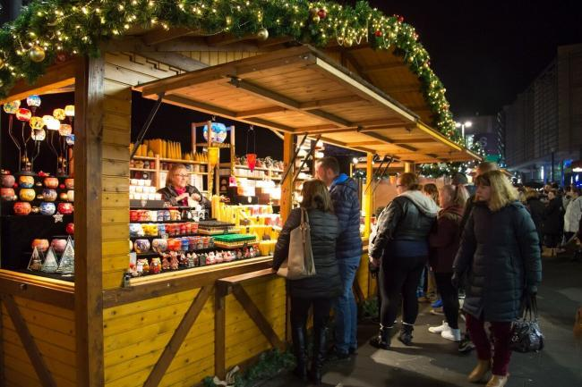
- NO trade waste can be put in bins provided by Hertford Town Council. Traders caught doing so will be fined £50 and may be refused a pitch at other events.
- Traders are responsible for the health and safety of themselves and their staff on site and should provide accident & incident report forms to the event coordinator should they occur on site.
- No power is available for the chalet pitches.
- Power is only available for food and drink stall holders.
- Chalets are booked as seen, stall holders are welcome to decorate but must not cause any damage to the structure.
- Lighting will not be provided, you will be responsible for lighting your chalet/stall using battery powered lighting (if you have not booked power).
Hertford Town Council offices are open Monday to Friday 9.00am until 5pm (4pm on Fridays). The event coordinator works Monday to Wednesday (except event weeks when it’s Monday, Tuesday and Friday) from 8.30am until 5pm. Outside of these hours e-mails and telephones are not continuously monitored. If your e-mail has not been replied to by Friday 12noon before the event please call 01992552885.
If you would like to proceed with your booking then please complete the booking form and return along with:
- Payment. Please note for all payments of £100 or less, full payment is required. For payments over £100, please pay a deposit of 50% now and 50% TWO months before the event. – cheques to be made payable to ‘Hertford Town Council’, please state on the back on the cheque the name/s of the event/s you are booking onto and also your business trading name). Alternatively you can make a card payment over the phone by calling Sophie Archer-Mills on 01992 552885
- Please attach copies of your food hygiene training certificates, HACCP plans & safe systems of work, public liability insurance, electrical & LPG gas safety certificates, food hygiene rating certificate, where applicable.
- Risk Assessment to cover event (guidance can be found on our website page as follows: https://www.hertford.gov.uk/event-stall-holder-information/)
Bookings cannot be processed without these documents and your cheque will be returned.
Please return to: Sophie Archer-Mills, Hertford Town Council, Hertford Castle, Hertford, SG14 1HR
Telephone number: 01992 552885, Email address: sophie.archer-mills@hertford.gov.uk
Confirmation of booking will be sent via e-mail once your booking has been processed and accepted. Further information regarding the event set up, arrival times, facilities etc will be sent via e-mail at least one week before the event (check your junk mail if you have not received this).
Please tick if you would like to be kept up to date with opportunities from Hertford Town Council.
Hertford Town Council’s Privacy Notice can be viewed online at www.hertford.gov.uk/subscribe
I confirm I have read and understood the above information and agree with the terms of booking.

Signature:………………………………………

STALL HOLDER BOOKING FORM
CHRISTMAS AT HERTFORD CASTLE 2021

EVENT DATE: FRIDAY 26TH, SATURDAY 27TH, SUNDAY 28TH NOVEMBER
EVENT OPENING TIMES: 26TH 3PM – 8PM, 27TH & 28TH 11AM - 7PM
CONTACT NAME:…………………………………………………………………………………………………
BUSINESS TRADING NAME:………………………………………………………………………………………
PRODUCTS SOLD (specify exactly what you will be selling/offering, (include menu if available) and give full description of the stall)*:.……………………………………………………………………………………………..
……………………………………………………………………………………………………………………………………………………………………………………………………………………………………………………
LOCAL AUTHORITY VENDOR REGISTERED WITH:…………………………………………………………
CURRENT NATIONAL FOOD HYGIENE RATING:……………………………………………………………..
ADDRESS:……………………………………………………………………………………………………………
TELEPHONE:…………………………………………………………………………………………………………
EMAIL:…………………………………………………………………………………………………………………
*Bookings are accepted based on this information, if menu or products offered differ please inform the event coordinator immediately to ensure this does not overlap with another booking. Booking may be withdrawn if overlap occurs. You may also be requested to stop selling a certain product on the day of the event should this not have been specified on your booking form and duplicates another vendors product.

STALL SIZE
Single vehicle (3x3 metres) Pop up gazebo (3x3 metres) Large pitch (6x3 metres)

Pitch Options: Please tick pitch required
Prices are per day, pitches must be booked for the entirety of the event.
Main Lawn – Wooden Chalets (only 25 available) – fully installed
1. Food Produce Vendor – wooden chalet supplied (no power) £70
2. Craft / homeware / clothing / merchandise / jewellery – wooden chalet supplied (no power) £70
Note: chalets do not include lighting or power and are empty. It is the responsibility of the vendor to bring suitable battery lighting and displays for items.
Main Lawn
1. Food or Hot Drinks Vendor 3x3 pitch (no power) (Max 3 food & 1 hot drinks) £125
2. Alcoholic Drinks Vendor 3x3 pitch (no power) (only 1 pitch available) £200
3. Entertainment 3x3 (eg. face painting, arts & crafts, games) (no power) £45
Note: Entertainment stalls must bring suitable battery powered lighting for their stall.

POWER SUPPLY (Food & Drink Vendors only) £10
3 pin plug 16amp plug Amount required (in kw):…………………………
Please list all items that will require power:……………………………………………………………………………………… …………………………………………………………………………………………………………………………………………
Hertford Town Council no longer allow Petrol generators on site but power is available on request. Supply is limited and must be pre-booked and cannot be guaranteed. All information above must be completed for consideration.
Please indicate which power source will be used:

LPG Diesel Petrol Electrical generator Mains (provided by Hertford Town Council)
Other (please specify) No power required

