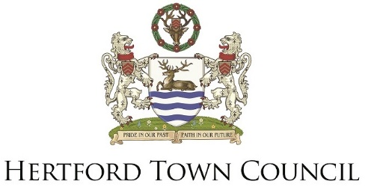

Ref: D&L//Hertford Markets Working Party

14 July 2017

TO: ALL MEMBERS OF HERTFORD MARKETS WORKING PARTY

Dear Councillor

A Meeting of the Hertford Markets Working Party will be held on:

MONDAY, 24 JULY 2017
IN THE ROBING ROOM, THE CASTLE, HERTFORD
AT 7.15 PM

The Agenda is attached.

Yours sincerely,

Mr J Whelan
Town Clerk

Councillors: P Boyle, S Cousins, B Deering, S Dunkley and J Sartin

AGENDA - MEETING OF THE HERTFORD MARKETS WORKING PARTY TO BE HELD ON MONDAY 24 JULY 2017 AT 7.15 PM IN THE ROBING ROOM, THE CASTLE, HERTFORD

- ELECTION OF CHAIRMAN

- ELECTION OF VICE CHAIRMAN

- APOLOGIES FOR ABSENCE

To receive apologies for absence.

- DECLARATIONS OF INTEREST

To receive Members’ declarations of Disclosable Pecuniary Interests (as defined by the Relevant Authorities (Disclosable Pecuniary Interests) Regulations 2012) where these Disclosable Pecuniary Interests:

- Have not already been entered into the register and
- Relate to a matter to be considered

To note that such interests so declared must be formally notified to Town Clerk and the Monitoring Officer at East Hertfordshire District Council of the interest within 28 days.

To receive Members’ declarations of Declarable Interests in accordance with Hertford Town Council’s Code of Conduct (adopted 8th April 2013).

- QUESTIONS AND/OR STATEMENTS FROM MEMBERS OF THE PUBLIC

Members of the public may speak about specific items on this agenda which contain a recommendation, provided they have advised the Town Clerk of their wish to speak no later than midday on the Friday before the meeting (or midday of the last working day of the week before the meeting). A list giving details of the name(s) and relevant agenda item(s) will be circulated to Councillors before the meeting commences.

- PROGRAMME

To approve the proposed strategy regarding the possible transfer of rights to license markets from the East Herts District Council to Hertford Town Council – PAPER A

